Technical Product Specification Paper

The PiPeWan project is aimed at creating a low-cost solution to monitoring water pipes. The system utilizes the capabilities of a LoRaWan system to help with the low cost. The LoRaWan system provides low-power long-range transmission and receiving signals with powerful penetration and anti-interference capabilities. The system will be used to monitor information about the water system within a building and it can then be used to alert building owners when there is a possibility of a leak, or when a pipe is leaking. It will also be used to help prevent the occurrence of pipes freezing through early notifications to users when the temperature of the pipe is trending towards a freezing point.

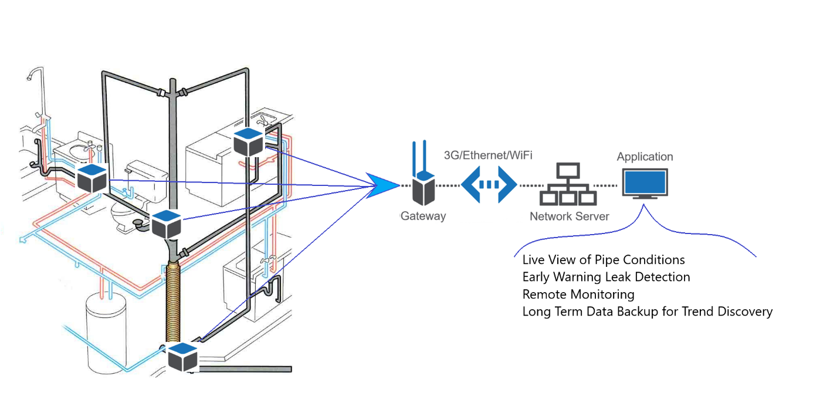

Realistic product constraints

Some of the limitations of our project include temperature, range, other RF messages, and placement of the flow sensor. These limitations mean that our nodes are limited where they can be placed. Our nodes must fit into the building area, this means that they need to fit wherever the pipes are inside the walls. Here is a list of some limitations we may encounter.

* Temperature: -20°C <-> 70°C
* Location: The node will be next to water pipes
* Interference: Other application operating on the same frequency band
* Placement: Flow sensor should be placed at a pipe junction or spliced into the pipe
* Antennae: Omni-directional antennae emit a 360° radiation signal with a relatively shorter range, so if nodes and gateways were farther apart signal will be weaker.
* Battery: Lithium batteries can drain at a rapid rate if exposed to extremely cold temperatures. We do experience such conditions in Kansas during winter months.

General requirements

* Indoors
* LoRaWan network (gateway and server)
* Lithium-Ion Battery DTP603450 – 3.7v 1Ah
* SparkFun Pro RF
* US902-928 Lora Standard with 915MHz Antenna
* Temperature sensors (Gikfun DS18B20 Waterproof sensor with Arduino Module)
* Water flow sensor (DIGITEN G3/4" Water Flow Hall Sensor Switch Flow Meter Flowmeter Counter 1-60L/min)
* Housing unit for Arduino and battery
* Rubber grommet to form watertight seal.

Hardware Considerations

1 x SparkFun Pro RF

* The SparkFun Pro RF works with the LoRaWan network and on the US915 band. It also has the capabilities of an Arduino so we can connect our sensors up to it and monitor information about the pipes.

1 x Omni-directional Antennae

* Can pick up and transmit signals reliably in a closed space, also provides redundancy.

1 x Temperature Sensor

* Waterproof and has adaptor module for Arduino.

1 x Flow sensor

* Waterproof, resistant to extreme temperatures, has adapter module for Arduino

1 x Lithium-Ion Battery

* The Lithium-Ion Battery will power the device, this battery should last a long time since our node will not constantly be sending information back to the server. This is because our node is a Class A LoRaWan device.

1 x 3D printed enclosure

* The Arduino and battery will be secured in a water-tight enclosure to protect the sensitive electronics from water and debris. The enclosure will be designed with an interference fit and a ledge for silicon. Epoxy can also be used to coat the vulnerable circuits if liquid shorts are a major concern. Two holes will be needed for the antenna and sensor wires to slip through. Each of these will be protected with a rubber grommet.

2 x Rubber grommet

* The rubber grommets will fit inside the hole in the enclosure and tighten to form a watertight seal over the antenna and sensor wires.

3 x Pipe Fasteners

* Two fasteners will be used to secure the enclosure to the pipe and the third will secure the temperature probe to the pipe.

Required product specifications

|  |  |  |
| --- | --- | --- |
| **Components** | **Specifications** | **Details/Standards** |
| SparkFun Pro RF | * 4.5 x 3.1 x 1cm * SAMD21G Microcontroller * MCP73831 Charge Management controller * RFM95W Transceiver * Operating temperature range -20°C to 70°C * Input supply voltage 3.3-6V. Recommended 3.7V * SAMD21 core 3.3V. Typical power between 3-17mA * RFM95W 3.3V. Typical receive power12mA. Typical transmit power 20-120mA | * Series of low-power microcontrollers ranging from 32- to 64-pins * Operates at a maximum frequency of 48MHz * Power supply voltage should not exceed 3.8V * Current into a VDD  pin should not exceed 92 mA * Current out of a GND pin should not exceed 130 mA * Storage temperature should not fall below -60°C or exceed 150°C |
| Omni-directional antennae | * Frequency: 915 MHz * Size: 8 –16 cm * Wavelength: ~33 cm * Location: In higher ground * Material: Copper | * US902-928 Lora Standard * FCC 15.247 regulations for applications operating on the 915 MHz band * IEEE Std. 145-1993: Standard Definitions of Terms for Antennas |
| Gikfun DS18B20 Temperature Temp Sensor Thermal Probe Thermometer Waterproof for Arduino | * Power supply range 3.0V to 5.5V * Operating temperature range: -55Â°C to +125Â°C (-67Â°F to +257Â°F) * Accuracy over the range of -10Â°C to +85Â°C: Â±0.5Â°C * Output lead: red (VCC), black (GND), yellow (DATA) * Cable length: 100 cm | * The DS18B20 digital thermometer provides 9-bit to 12-bit Celsius temperature measurements and has an alarm function with nonvolatile user-programmable upper and lower trigger points. * The DS18B20 communicates over a 1-Wire bus that requires only one data line (and ground) for communication with a central microprocessor. * In addition, the DS18B20 can derive power directly from the data line (“parasite power”), eliminating the need for an external power supply. * Each DS18B20 has a unique 64-bit serial code, which allows multiple DS18B20s to function on the same 1-Wirebus. |
| DIGITEN G3/4” Water Flow Sensor | * Flow range: 1-60L/min * 15cm or 120cm cable * Operating Temp: <= 80°C * Voltage Range: DC 5-24 V * Max current:15 mA (DC 5V) | * In line with ROHS testing standards * Works with Arduino * In line with pipes * Gets power from Arduino |
| Lithium-Ion Battery | * 3.3V 1Ah * 2-pin JST-PH connector * 2.00 x 1.32 x 0.23" (50.8 x 33.5 x 5.9 mm) | * OSHA 1926.441: batteries and battery charging. * ANSI C18.2M Part 2: Portable Rechargeable Cells and Batteries- Safety Standard. |

Software Details

Arduino Code: This program will collect information from the varying sensors and then report it back to the LoRaWan server. We will collect temperature and flow rate information.

Server: The server is running the ChirpStack program, this controls the gateways and then outputs information via MQTT.

Application: Our program will listen on the MQTT server and then report information back to building owners, showing information such as temperature and flowrate. Our application will also warn building owners when their pipes are having issues such as freezing, or excessive flow.

Software requirements:

* Internet access
* Visual studio
* C# .NET libraries
* GitHub repository
* LoRaWan gateway and server access
* Arduino IDE
* LMIC (MCCI) LoRaWan for Arduino library

Appropriate engineering standards that must be considered for the product or project design.

* US902-928 Lora Standard
* ROHS compliance for flow sensors
* FCC 15.247 emission standards for using the unlicensed 902-928 band.
* IEEE Std. 145-1993: Standard Definitions of Terms for Antennas
* OSHA 1926.441: batteries and battery charging.
* ANSI C18.2M Part 2: Portable Rechargeable Cells and Batteries- Safety Standard.
* ESFI Standards and best practices for Electric Safety

Works Cited

[1] SparkFun Pro RF: <https://www.sparkfun.com/products/15836>

[2] SparkFun Pro RF RFM95W: <https://cdn.sparkfun.com/assets/learn_tutorials/8/0/4/RFM95_96_97_98W.pdf>

[3] SparkFun Pro RF MCP73831: <https://cdn.sparkfun.com/datasheets/Components/General%20IC/33244_SPCN.pdf>

[4] SparkFun Pro RF SAMD21G: <https://cdn.sparkfun.com/assets/6/3/d/d/2/Atmel-42181-SAM-D21_Datasheet.pdf>

[5] Battery regulations: <https://www.osha.gov/laws-regs/regulations/standardnumber/1926/1926.441>

[6] DIGITEN G3/4” Water Flow Sensor: <https://www.openhacks.com/uploadsproductos/g3_4_water_flow_sensor_-_wiki.pdf>

[7] FCC regulations: <https://transition.fcc.gov/Bureaus/Engineering_Technology/Orders/1997/fcc97114.txt>

[8] Gikfun DS18B20 Temperature Temp Sensor Thermal Probe Thermometer Waterproof for Arduino: <https://datasheets.maximintegrated.com/en/ds/DS18B20.pdf>

[9] "IEEE Standard for Definitions of Terms for Antennas," in IEEE Std 145-2013 (Revision of IEEE Std 145-1993) , vol., no., pp.1-50, 6 March 2014, doi: 10.1109/IEEESTD.2014.6758443.

[10] Portable Rechargeable Cells and Batteries- Safety Standard: <https://blog.ansi.org/2020/06/ansi-c182m-portable-rechargeable-cell-batteries/#gref>